Subject : Proposal to host Android Pakistan Community Meetup at Dadabhoy Institute of Higher Education Main Campus

On 13-January-2018 Android Pakistan Community will host an “Android Pakistan Community Meetup”.
I am the founder of Android Pakistan Community, later most of the students of mine and friends joined this community to serve for the betterment of Mobile Application Development in Pakistan.

Android Pakistan Community is non-profit and non-government organization which supports and promote Android Technologies, events, get to-gather and conferences initially in Karachi later on Pakistan. Android Pakistan Community also aims to support students and professional to promote their work related to Android Technologies.

We are going to host this event in Dadabhoy Institute of Higher Education (Main Campus) and we are planning to invite the audience from the different software houses of Karachi and universities students to attend this event which is expected to be 100 to 150 head count.

This event will be consist of two sections following.

1) We are also planning to invite at least 3 -5 successful business person who are currently in I.T industries and serving their best growing I.T in Pakistan.
2) 4 to 5 Tech-talks session regarding Android Technologies will be given by seniors of different software houses of Karachi.

We are also planning some refreshments for the audience and guests as well.

We have planned that we will have standee, wall standee, selfie both (if possible) wallpapers with panaflex with company logo of our partners and sponsors for physical branding.

YOUR BENEFITS:
Our team will be fully responsible to promote your company in their every promotion regarding the event.

To promote this event our social media team will post banners, posters, speaker details, sponsors, partners detail with their profile and company logo to various social media sites.

We will recognize your Institute representative.

We have also planned to provide a souvenir as a gift to our every guest and with company logo of our partners and sponsors.

Android Pakistan Community team will provide souvenir to your Institute representative.
Your Institute logo will be placed in every social media branding as well as Physical branding throughout the event.

ARRANGEMENT EXPECTATION:
Our team is expecting you to arrange a conference hall with individual sittings arrangements for our guest and speakers
We will also require a projector, rostrum, electricity and internet connection.
It would be nice if your institute arrange small stage see below image (not similar to below image but something like that if it is possible.)
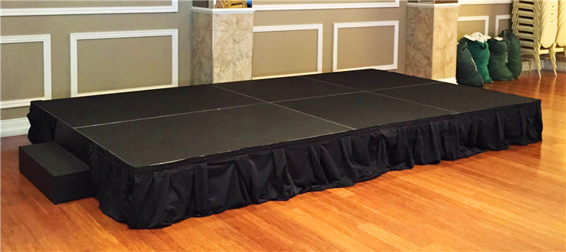

Regards
Yasir Ameen (Founder) and Team Android Pakistan Community

For Contact:
Yasir Ameen (03333426401)
Muhammad Ibrahim (03322141597)

